**Student Name: Anushri Srinath Aithal**

**Student ID: 012506897**

**Assignment#3 Currency Converter**

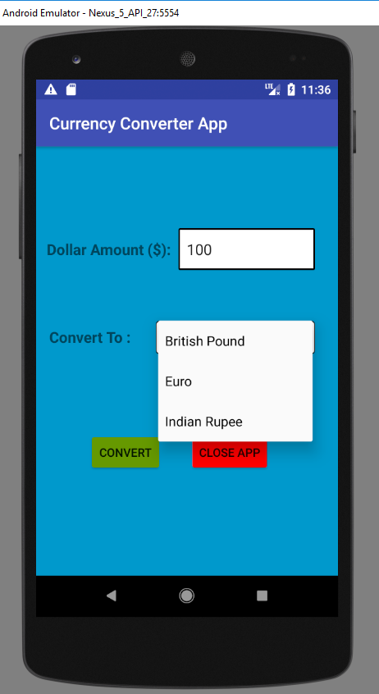

Fig.1 Currency Converter App Sender App that takes input amount and the denomination to which we must convert.

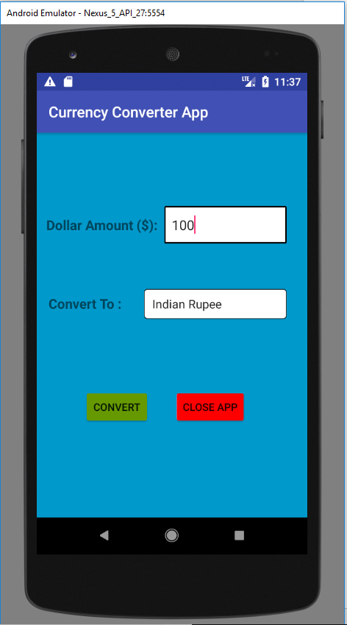

Fig.2 Sender App sends a broadcast with amount and denomination to which it needs to be converted to the Receiver App. When Convert button is clicked broadcast is sent to receiver app where actual conversion is done.

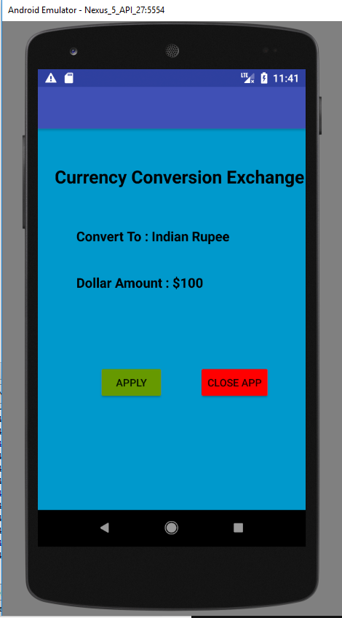

Fig.3 Currency Converter Receiver App that picks the broadcast and displays the amount to be converted to the value that needs to be exchanged. When apply button is clicked the currency is converted to other denomination and then broadcasted back to the sender app.

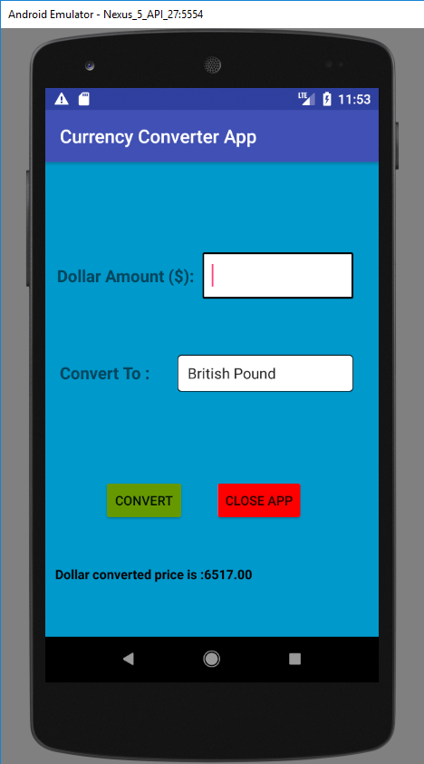

Fig.4 Sender app receives the broadcast from receiver app the value that is converted and displays it on screen.